1. Design PDA using simulator to accept the input string anb2n

**OUTPUT:**

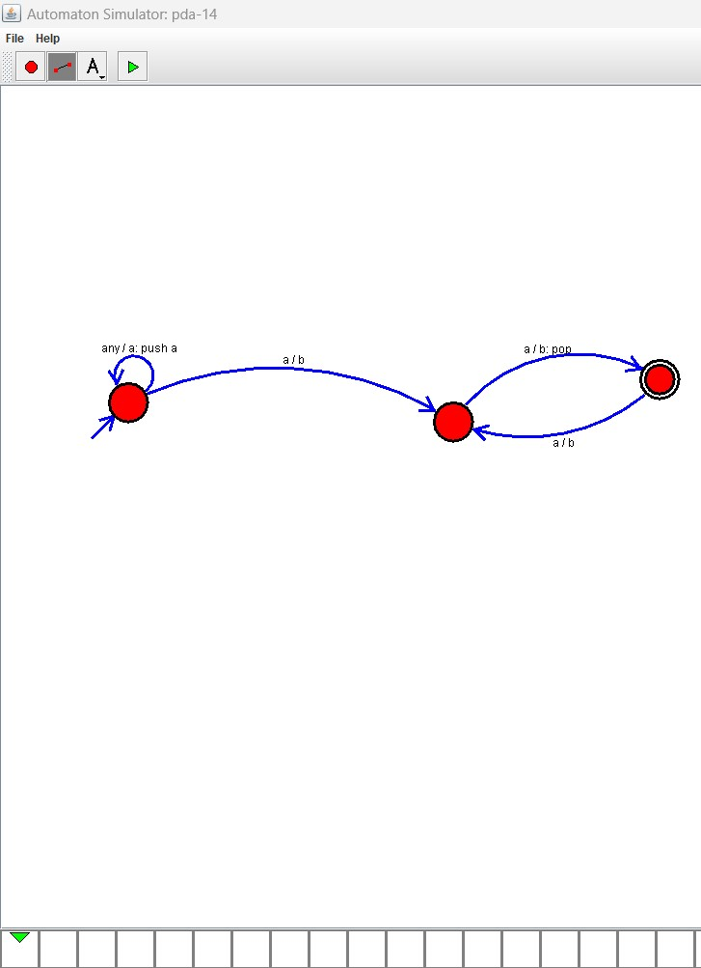

**RESULT:** THE PDA RUN SUCCESFULLY USING SIMULATOR BASED ON GIVEN STRINGS